█████████████████████████████████
█████████████████████████████████████████████████████████████████ – CONTRACT █████

Schedule Update 3.02.26 F00 NARRATIVE

March 4, 2026

Subject: █████████████████████████████████ – Contract No. █████ Schedule 3.02.26 F00

Pursuant to the project specifications, please find attached the cost-loaded schedule update for the █████████████████████████████████████████████████████████████████ Contract █████. The schedule submitted represents our understanding of project documents as well as our assumptions, discussion with our trade partners, and the utilized means, and methods. Schedule submitted captures all work carried out from February 2, 2026 to March 2, 2026.

This period ███ started the pipe cleaning of new sections and the frame and cover for Manholes located on Phase 2 and 3. Bypass was installed as planned for Phase 3 scope. The work completed this period is shown on the attached Pay Application. Some submittals were closed this period while others remain on █████’s court for review and approval.

Paving and stripping was also completed in conjunction with MH rehabilitation and is expected to continue as the project progresses.

(1) Inclement weather event was recorded this period on 2/19/26 and as result the rain allowance was reduced this period from 37 to 36 days. Despite pipe cleaning no grout was completed this period.

The stipulated work plan shown for this period and anticipated durations are subject to change and dependent on information and the existing conditions known at the time.

The last approved quantity reported for schedule update (DD 2.02.26 F01) was $578,235.42.

The estimated value of work completed for this period 3.02.26 F00 is $796,316.81. The final billed
amount has remained unchanged after █████ review and is represented accurately on the final F00
scheduling update.

█████ DD 3.02.26 D00 Schedule Review Comments

████ Comment #1: The Contractor shall specify in their narrative the changes that caused the project total float, critical activities, substantial and final completion to deviate from the previous period.

███ Response #1: The previously submitted schedule update with a Data Date of February 2, 2026, showed projected Substantial and Final Completion dates of September 3, 2027, and October 28, 2027, respectively. At that time, the schedule indicated the longest path running through Bypass 6 submittal and installation, followed by Phase 3 MH rehabilitation. The Total Float for activities tied to Substantial Completion showed the project to be 50 days ahead of schedule.

In the current update, the projected Substantial and Final Completion dates have improved, reflecting earlier completion dates compared to the previous period. The updated dates are April 27, 2027, and June 21, 2027, respectively. The schedule now shows the longest path running through Bypass 7 submittal, preparation, and installation, followed by Phase 2 MH rehabilitation, instead of Bypass 6 submittal and installation. This shift can be attributed to the completion of Bypass 6 installation during this period, which has removed that work from the critical path. In addition, ███ has started and/or completed other critical and near-critical activities, shifted Bypass 4 and 5 to begin during the school summer break, and worked out of sequence to open new areas of work..

A screenshot of the Longest Paths from the previous period has been included to illustrate more accurately the changes in the critical path.

Various critical activities shown previously on the Longest Path DD 02.02.26 F00 have started and completed this period. In some instances, activities have started out-of-sequence. The critical activities from the Longest Path that started and / or completed this period are highlighted in Orange on the Images below and shown as part of the Pay Application this period.

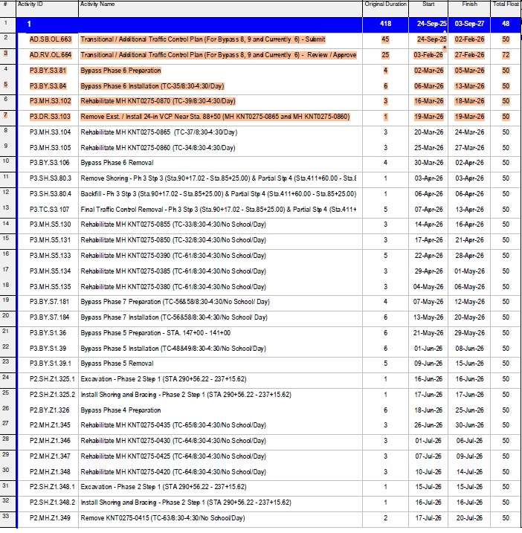

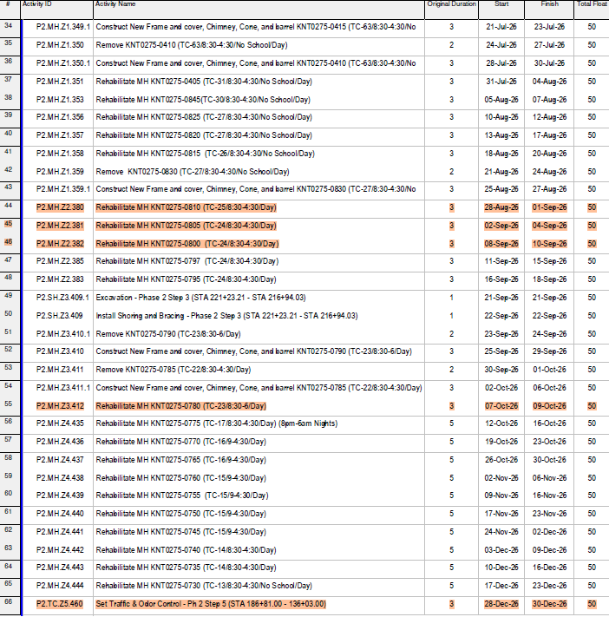
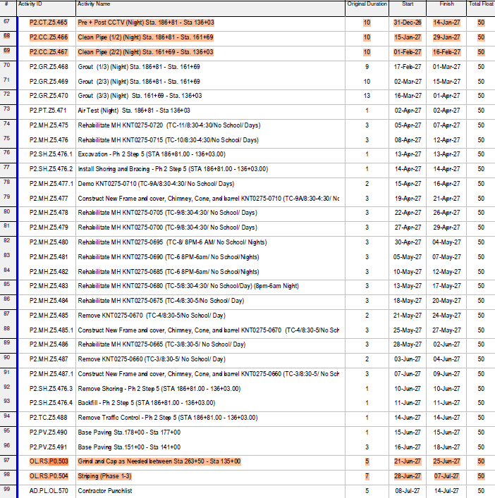

Below is a table showing activities that started this period:

Task ID | Task Name | Actual Start Date
AD.RV.OL.749 | Temp Handling of Flow Bypass 6 Plan - Review / Approve | 01/23/2026
AD.RV.OL.601 | Manhole Field Measurements / Shop Drawings - Review / Approve | 12/29/2025
AD.PR.OL.603 | Manhole Field Measurements / Shop Drawings - Procurement | 01/07/2026
P2.MH.Z1.354 | Rehabilitate MH KNT0275-0840 (TC-29/8:30-4:30/No School/Day) | 12/30/2025
P2.MH.Z1.355 | Rehabilitate MH KNT0275-0835 (TC-28/8:30-4:30/No School/Day) | 12/30/2025
P2.TC.Z3.400 | Set Traffic & Odor Control - Phase 2 Step 3 (STA 221+23.21 - STA 216+94.03) | 01/08/2026
P2.CT.Z3.405 | Pre + Post CCTV (Night) Sta. 221+23.21 - Sta. 216+94.03 | 01/08/2026
P2.CC.Z3.406 | Clean Pipe (Night) Sta. 221+23.21 - Sta. 216+94.03 | 01/08/2026
P2.TC.Z4.420 | Set Traffic & Odor Control - Ph 2 Step 4 (STA 216+94.03 - STA 194+53.13) & Partial Step 5 (194+53.13 - STA 186+81) | 01/14/2026
P2.CT.Z4.425 | Pre + Post CCTV (Night) Sta. 216+94.03 - Sta. 186+81 | 01/14/2026
P2.CC.Z4.426 | Clean Pipe (1/2) (Night) Sta. 216+94.03 - Sta. 201+92 | 01/14/2026
P2.CC.Z4.427 | Clean Pipe (2/2) (Night) Sta. 201+92 - Sta. 186+81 | 01/22/2026
P3.RS.S1.78 | Cross Gutter, Slurry | 01/13/2026
P3.MH.S1.66 | Rehabilitate MH KNT0275-0900 (TC-44/8:30-4:30/Day) | 01/15/2026
P3.MH.S6.165 | Rehabilitate MH KNT0275-0375 (TC-60/8:30-4:30/ Day) | 01/26/2026
P3.MH.S6.166 | Rehabilitate MH KNT0275-0370 (TC-60/8:30-4:30/ Day) | 01/27/2026
P3.MH.S6.167 | Rehabilitate MH KNT0275-0365 (TC-60/8:30-4:30/ Day) | 01/28/2026
P3.MH.S6.168 | Rehabilitate MH KNT0275-0360 (TC-59/8:30-4:30/ Day) | 01/16/2026
P3.MH.S6.169 | Rehabilitate MH KNT0275-0355 (TC-58/8:30-4:30/ Day) | 01/29/2026
P3.CC.S7.217 | Clean Pipe (2/2) (Night) Sta. 40+00 - Sta. 34+00 | 01/11/2026

Below is a table showing activities that completed this period:

Task ID | Task Name | Actual End Date
AD.RV.OL.670 | Pre-Construction Survey Data - Review / Approve | 01/05/2026
AD.RV.OL.708 | Initial CCTV Inspection Video and Report - Review / Approve | 01/06/2026
AD.PR.OL.718 | VCP Pipe/Fitting Product Data - Procurement / Delivery | 01/08/2026
AD.PR.OL.725 | CIPM Product Data - Procurement / Delivery | 01/06/2026
AD.RV.OL.731 | Video / Audio of Testing / Grouting - Review / Approve | 01/06/2026
AD.SB.OL.748 | Temp Handling of Flow Bypass 6 Plan - Submit | 01/23/2026
AD.SB.OL.600 | Manhole Field Measurements / Shop Drawings - Submit | 12/29/2025
AD.RV.OL.601 | Manhole Field Measurements / Shop Drawings - Review / Approve | 12/30/2025
P2.CC.Z2.376 | Clean Pipe (Night) Sta. 236+93 - Sta. 221+23.21 | 12/19/2025
P2.CT.Z3.405 | Pre + Post CCTV (Night) Sta. 221+23.21 - Sta. 216+94.03 | 01/14/2026
P2.CC.Z3.406 | Clean Pipe (Night) Sta. 221+23.21 - Sta. 216+94.03 | 01/14/2026
P2.CC.Z4.426 | Clean Pipe (1/2) (Night) Sta. 216+94.03 - Sta. 201+92 | 01/21/2026
P2.CC.Z4.427 | Clean Pipe (2/2) (Night) Sta. 201+92 - Sta. 186+81 | 01/30/2026
P3.RS.S1.78 | Cross Gutter, Slurry | 01/14/2026
P3.MH.S1.64 | Rehabilitate MH KNT0275-0910 (TC-45/8:30-4:30/Day) (8pm-6am Night) | 01/08/2026
P3.MH.S1.66 | Rehabilitate MH KNT0275-0900 (TC-44/8:30-4:30/Day) | 01/23/2026
P3.MH.S1.67 | Rehabilitate MH KNT0275-0895 (TC-43/8:30-4:30/Day) | 01/22/2026
P3.MH.S1.68 | Rehabilitate MH KNT0275-0890 (TC-42/8:30-4:30/Day) | 01/21/2026
P3.MH.S1.69 | Rehabilitate MH KNT0275-0885 (TC-42/8:30-4:30/Day) | 01/20/2026
P3.MH.S1.35 | Rehabilitate MH KNT0275-0935 (TC-52/8:30-4:30/Day) | 01/06/2026
P3.MH.S3.100 | Rehabilitate MH KNT0275-0880 (TC-41/8:30-4:30/Day) | 01/08/2026
P3.CC.S7.216 | Clean Pipe (1/2) (Night) Sta. 47+75 - Sta. 40+00 | 01/11/2026

Below is a table showing activities that started and completed this period:

Task ID | Task Name | Actual Start Date | Actual End Date
AD.RV.OL.601 | Manhole Field Measurements / Shop Drawings - Review / Approve | 12/29/2025 | 12/30/2025
P2.CT.Z3.405 | Pre + Post CCTV (Night) Sta. 221+23.21 - Sta. 216+94.03 | 01/08/2026 | 01/14/2026
P2.CC.Z3.406 | Clean Pipe (Night) Sta. 221+23.21 - Sta. 216+94.03 | 01/08/2026 | 01/14/2026
P2.CC.Z4.426 | Clean Pipe (1/2) (Night) Sta. 216+94.03 - Sta. 201+92 | 01/14/2026 | 01/21/2026
P2.CC.Z4.427 | Clean Pipe (2/2) (Night) Sta. 201+92 - Sta. 186+81 | 01/22/2026 | 01/30/2026
P3.RS.S1.78 | Cross Gutter, Slurry | 01/13/2026 | 01/14/2026
P3.MH.S1.66 | Rehabilitate MH KNT0275-0900 (TC-44/8:30-4:30/Day) | 01/15/2026 | 01/23/2026

Below is dashboard of all changes that occurred between DD 260202 F01 to DD 260302 F00 schedule updates:
Below is dashboard of all changes that occurred between January 5, 2026 to February 2, 2026 updates:

- Activities added, 8
- Activities deleted, 0
- Activity name changed, 2
- Actualized date changed, 35
- Original activity duration changed, 5
- Started this period, 20
- Completed this period, 22
- Started & completed this period, 7
- Added logic ties, 64
- Deleted logic ties, 22
- Relationship changes, 1
- Lag value changes, 0

- Activity description changes, 3
- Original duration changes, 1
- Activities deleted, 0
- Activities added, 6
- Relationship changes, 12
- Lag value changes, 0
- Added predecessors, 54
- Deleted predecessors, 26
- Started this period, 22
- Completed this period, 14
- Started & completed this period, 7

All changes to the file can be found on the excel spreadsheet named “█████ ████████████ – 260302 F00 - SCHEDULE COMPARISON - DD 260202 F01 TO DD 260302 F00.”

KEY MILESTONE DATES

- Substantial Completion (was November 6, 2027)  - Final Completion (was January 6, 2028) | September 3, 2027  October 28, 2027

- Notice to Proceed  - Contract Substantial Completion  - Contract Project Completion  - Substantial Completion (Projected)  - Project Completion (Projected) | Feb 13, 2025  Nov 13, 2027  Jan 12, 2028  April 27, 2027  June 21, 2027
Added Activities, (8)

Activity ID | Description | Duration
UP.DD.02.02.26-01 | IntermediaryTraff.Con.Part3-Ph3Stp3(Sta.90+17.02- Sta.85+25.00)&PartialStp4(Sta.411+60.00-Sta.85+25.00) | 1
UP.DD.02.02.26-02 | IntermediaryTrafficControlPart3-Phase3Step6(STA61+50.00- STA47+75.20) | 1
UP.DD.02.02.26-03 | IntermediateTrafficControlPart2-Phase3Step8(STA34+00- STA13+64.71) | 1
UP.DD.02.02.26-04 | IntermediaryTrafficRem.Part2-Phase2Step1(STA290+56.22- 237+15.62) | 1
UP.DD.02.02.26-05 | IntermediaryTrafficControl-Phase2Step2(STA236+93.62-STA 221+23.21) | 1
UP.DD.02.02.26-06 | IntermediaryTrafficControl-Phase2Step3(STA221+23.21-STA 216+94.03) | 1
UP.DD.02.02.26-07 | IntermediaryTrafficControl-Part1Ph2Step4(STA216+94.03- STA194+53.13)&PartialStep5(194+53.13-STA186+81) | 1
UP.DD.02.02.26-08 | IntermediaryTrafficControl-Part2Ph2Step4(STA216+94.03- STA194+53.13)&PartialStep5(194+53.13-STA186+81) | 5

- New activities added to capture work performed this period.
Deleted Activities, (0)

None to report.

Activity Name Changes, (2)

Activity ID | Original Description | New Description
UP.DD.01.05.26-03 | IntermediateTrafficControl-Phase3Step8(STA34+00-STA 13+64.71) | IntermediateTrafficControlPart1-Phase3Step8(STA34+00 -STA13+64.71)
UP.DD.10.13.25-06 | IntermediaryTrafficRem.-Phase2Step1(STA290+56.22- 237+15.62) | IntermediaryTrafficRem.Part1-Phase2Step1(STA 290+56.22-237+15.62)

- Descriptions revised to depict more accurately the project scope
Actualized Date Changes, (0)

None to report.

Original Duration Changes, (3)

Activity ID | Description | Original Duration A | Original Duration B
AD.ML.P0.06 | ProjectInclementWeatherAllowance(42Days) | 38 | 37
UP.DD.01.05.26-01 | IntermediaryTrafficCont(Pt.2)Ph3Stp1(Sta.146+37.50 to141+00)Stp2(Sta.157+14.01to135+60)Stp4Sta.135+60 to110+60 | 5 | 1
UP.DD.01.05.26-03 | IntermediateTrafficControl-Phase3Step8(STA34+00- STA13+64.71) | 5 | 1

- Weather allowance reduced to capture inclement weather on 2/19/26.

Relationship Changes, (9)

Activity ID | Description | Pred ID | Pred Description | Rel A | Rel B
P2.CC.Z4.426 | CleanPipe(1/2)(Night)Sta. 216+94.03-Sta.201+92(Not Start) | P2.CT.Z4.425 | Pre+PostCCTV(Night)Sta. 216+94.03-Sta.186+81 (Active) | FS0 | SS0
P2.CT.Z3.405 | Pre+PostCCTV(Night)Sta. 221+23.21-Sta.216+94.03 (NotStart) | P2.TC.Z3.400 | SetTraffic&OdorControl- Phase2Step3(STA 221+23.21-STA216+94.03) (Active) | FS0 | SS0
P2.CT.Z4.425 | Pre+PostCCTV(Night)Sta. 216+94.03-Sta.186+81(Not Start) | P2.TC.Z4.420 | SetTraffic&OdorControl-Ph 2Step4(STA216+94.03-STA 194+53.13)&PartialStep5 (194+53.13-STA186+81) (Active) | FS0 | SS0
P3.BY.S1.36 | BypassPhase5Preparation- STA.147+00-141+00(Not Start) | P3.BY.S7.184 | BypassPhase7Installation (TC-56&58/8:30-4:30/No School/Day)(NotStart) | FS4 | FS0
P3.MH.S6.165 | RehabilitateMHKNT0275- 0375(TC-60/8:30-4:30/Day) (NotStart) | P3.TC.S6.150 | SetTraffic&OdorControl/ MHMst-Phase3Step6(STA 61+50.00-STA47+75.20) (Active) | FS0 | SS0
P3.MH.S6.165 | RehabilitateMHKNT0275- 0375(TC-60/8:30-4:30/Day) (NotStart) | P3.PT.S6.160 | AirTest(Night)Sta.61+50- Sta.47+75.20(183Joints) (Active) | FS0 | SS0
P3.MH.S6.166 | RehabilitateMHKNT0275- 0370(TC-60/8:30-4:30/Day) (NotStart) | P3.MH.S6.165 | RehabilitateMHKNT0275- 0375(TC-60/8:30-4:30/Day) (Active) | FS0 | SS0
P3.MH.S6.167 | RehabilitateMHKNT0275- 0365(TC-60/8:30-4:30/Day) (NotStart) | P3.MH.S6.166 | RehabilitateMHKNT0275- 0370(TC-60/8:30-4:30/Day) (Active) | FS0 | SS0
P3.MH.S6.169 | RehabilitateMHKNT0275- 0355(TC-58/8:30-4:30/Day) (NotStart) | P3.MH.S6.168 | RehabilitateMHKNT0275- 0360(TC-59/8:30-4:30/Day) (Active) | FS0 | SS0

- Logic relationships were modified to reflect out of sequence and work concurrency in the field.
Lag Value Changes, (0)

None to report.

Added Predecessors, (57)

Activity ID | Description | Pred ID | Pred Description | Rel
P1.TC.T1.235 | SetTraffic&OdorControl-Ph1Stp1 (343+97.30-332+07.23)&Stp2(STA 332+07.23-STA290+56.22)(Not Start) | P3.MH.S6.165 | RehabilitateMHKNT0275-0375(TC- 60/8:30-4:30/Day)(Active) | FS0
P2.CC.Z4.426 | CleanPipe(1/2)(Night)Sta. 216+94.03-Sta.201+92(Complete) | P2.CC.Z3.406 | CleanPipe(Night)Sta.221+23.21- Sta.216+94.03(Complete) | FS0
P2.CT.Z3.405 | Pre+PostCCTV(Night)Sta. 221+23.21-Sta.216+94.03 (Complete) | AD.NT.P0.22 | CityofHawaiianGardensNotification ofWork(Complete) | FS0
P2.CT.Z3.405 | Pre+PostCCTV(Night)Sta. 221+23.21-Sta.216+94.03 (Complete) | AD.RV.OL.646 | CityofOrangeCountyPublicWorks EncroachmentPermit-Review/ Approve(Complete) | FS0
P2.CT.Z4.425 | Pre+PostCCTV(Night)Sta. 216+94.03-Sta.186+81(Active) | P2.CC.Z3.406 | CleanPipe(Night)Sta.221+23.21- Sta.216+94.03(Complete) | FS0
P2.GR.Z4.428 | Grout(1/2)(Night)Sta.216+94.03- Sta.201+92(NotStart) | P2.CT.Z4.425 | Pre+PostCCTV(Night)Sta. 216+94.03-Sta.186+81(Active) | FS0
P2.MH.Z1.354 | RehabilitateMHKNT0275-0840(TC- 29/8:30-4:30/NoSchool/Day)(Active) | UP.DD.10.13.25-06 | IntermediaryTrafficRem.Part1- Phase2Step1(STA290+56.22- 237+15.62)(Complete) | FS0
P2.MH.Z1.355 | RehabilitateMHKNT0275-0835(TC- 28/8:30-4:30/NoSchool/Day)(Active) | UP.DD.10.13.25-06 | IntermediaryTrafficRem.Part1- Phase2Step1(STA290+56.22- 237+15.62)(Complete) | FS0
P2.MH.Z1.356 | RehabilitateMHKNT0275-0825(TC- 27/8:30-4:30/NoSchool/Day)(Not Start) | P2.MH.Z1.353 | RehabilitateMHKNT0275-0845(TC- 30/8:30-4:30/NoSchool/Day)(Not Start) | FS0
P2.MH.Z1.356 | RehabilitateMHKNT0275-0825(TC- 27/8:30-4:30/NoSchool/Day)(Not Start) | P2.MH.Z1.354 | RehabilitateMHKNT0275-0840(TC- 29/8:30-4:30/NoSchool/Day)(Active) | FS0
P2.MH.Z4.435 | RehabilitateMHKNT0275-0775(TC- 17/8:30-4:30/Day)(8pm-6amNights) (NotStart) | P2.MH.Z3.412 | RehabilitateMHKNT0275-0780(TC- 23/8:30-6/Day)(NotStart) | FS0
P2.SH.Z1.325.1 | Excavation-Phase2Step1(STA 290+56.22-237+15.62)(NotStart) | P3.BY.S1.39.1 | BypassPhase5Removal(NotStart) | FS0
P2.SH.Z1.325.1 | Excavation-Phase2Step1(STA 290+56.22-237+15.62)(NotStart) | P1.DR.T1.242 | Install26"DR17(Sta.322+62.23to Sta.317+00)(NotStart) | FS0
P2.SH.Z3.409.1 | Excavation-Phase2Step3(STA 221+23.21-STA216+94.03)(Not Start) | P2.MH.Z2.383 | RehabilitateMHKNT0275-0795(TC- 24/8:30-4:30/Day)(NotStart) | FS0
P2.TC.Z1.360 | RemoveTrafficControl-Phase2Step 1(STA290+56.22-237+15.62)(Not Start) | UP.DD.02.02.26-04 | IntermediaryTrafficRem.Part2- Phase2Step1(STA290+56.22- 237+15.62)(Complete) | FS0
P2.TC.Z2.384 | RemoveTrafficControl-Phase2Step 2(STA236+93.62-STA221+23.21) (NotStart) | UP.DD.02.02.26-05 | IntermediaryTrafficControl-Phase2 Step2(STA236+93.62-STA 221+23.21)(Complete) | FS0
P2.TC.Z3.400 | SetTraffic&OdorControl-Phase2 Step3(STA221+23.21-STA 216+94.03)(Active) | AD.NT.P0.22 | CityofHawaiianGardensNotification ofWork(Complete) | FS0
P2.TC.Z3.400 | SetTraffic&OdorControl-Phase2 Step3(STA221+23.21-STA 216+94.03)(Active) | AD.RV.OL.646 | CityofOrangeCountyPublicWorks EncroachmentPermit-Review/ Approve(Complete) | FS0
P2.TC.Z3.413 | RemoveTrafficControl-Phase2Step 3(STA221+23.21-STA216+94.03) (NotStart) | UP.DD.02.02.26-06 | IntermediaryTrafficControl-Phase2 Step3(STA221+23.21-STA 216+94.03)(Complete) | FS0
P2.TC.Z4.420 | SetTraffic&OdorControl-Ph2Step 4(STA216+94.03-STA194+53.13)& PartialStep5(194+53.13-STA 186+81)(Active) | AD.NT.P0.22 | CityofHawaiianGardensNotification ofWork(Complete) | FS0
P2.TC.Z4.420 | SetTraffic&OdorControl-Ph2Step 4(STA216+94.03-STA194+53.13)& PartialStep5(194+53.13-STA 186+81)(Active) | AD.RV.OL.646 | CityofOrangeCountyPublicWorks EncroachmentPermit-Review/ Approve(Complete) | FS0
ActivityID | Description | PredID | PredDescription | Rel
P2.TC.Z4.420 | SetTraffic&OdorControl-Ph2Step 4(STA216+94.03-STA194+53.13)& PartialStep5(194+53.13-STA 186+81)(Active) | UP.DD.02.02.26-06 | IntermediaryTrafficControl-Phase2 Step3(STA221+23.21-STA 216+94.03)(Complete) | FS0
P2.TC.Z4.446 | RemoveTrafficControl-Phase2Step 4(STA216+94.03-STA194+53.13)& PartialStep5(194+53.13-STA 186+81)(NotStart) | UP.DD.02.02.26-07 | IntermediaryTrafficControl-Part1Ph 2Step4(STA216+94.03-STA 194+53.13)&PartialStep 5(194+53.13-STA186+81) (Complete) | FS0
P2.TC.Z4.446 | RemoveTrafficControl-Phase2Step 4(STA216+94.03-STA194+53.13)& PartialStep5(194+53.13-STA 186+81)(NotStart) | UP.DD.02.02.26-08 | IntermediaryTrafficControl-Part2Ph 2Step4(STA216+94.03-STA 194+53.13)&PartialStep 5(194+53.13-STA186+81) (Complete) | FS0
P3.BV.S3.110 | BasePavingSta.90+17-Sta.85+25 (NotStart) | P3.PV.S1.76 | BasePavingSta.146+50-Sta. 140+00(NotStart) | FS0
P3.BY.S7.181 | BypassPhase7Preparation(TC- 56&58/8:30-4:30/NoSchool/Day) (NotStart) | P3.MH.S5.135 | RehabilitateMHKNT0275-0380(TC- 61/8:30-4:30/NoSchool/Day)(Not Start) | FS0
P3.MH.S1.60 | RehabilitateMHKNT0275-0930(TC- 51/8:30-4:30/NoSchool/Day)(Not Start) | P3.BY.S1.39 | BypassPhase5Installation(TC- 48&49/8:30-4:30/NoSchool/Day)(Not Start) | FS0
P3.MH.S1.60 | RehabilitateMHKNT0275-0930(TC- 51/8:30-4:30/NoSchool/Day)(Not Start) | P3.MH.S1.65 | RehabilitateMHKNT0275-0905(TC- 44/8:30-4:30/Day)(NotStart) | FS0
P3.MH.S1.60 | RehabilitateMHKNT0275-0930(TC- 51/8:30-4:30/NoSchool/Day)(Not Start) | P3.MH.S1.66 | RehabilitateMHKNT0275-0900(TC- 44/8:30-4:30/Day)(Complete) | FS0
P3.MH.S1.63 | RehabilitateMHKNT0275-0915(TC- 46/8:30-4:30/NoSchool/Day)(Not Start) | P3.MH.S1.66 | RehabilitateMHKNT0275-0900(TC- 44/8:30-4:30/Day)(Complete) | FS0
P3.MH.S1.66 | RehabilitateMHKNT0275-0900(TC- 44/8:30-4:30/Day)(Complete) | P3.MH.S1.67 | RehabilitateMHKNT0275-0895(TC- 43/8:30-4:30/Day)(Complete) | FS0
P3.MH.S6.165 | RehabilitateMHKNT0275-0375(TC- 60/8:30-4:30/Day)(Active) | P3.MH.S6.168 | RehabilitateMHKNT0275-0360(TC- 59/8:30-4:30/Day)(Active) | SS0
P3.MH.S6.166 | RehabilitateMHKNT0275-0370(TC- 60/8:30-4:30/Day)(Active) | UP.DD.02.02.26-02 | IntermediaryTrafficControlPart3- Phase3Step6(STA61+50.00-STA 47+75.20)(Complete) | FS0
P3.MH.S6.167 | RehabilitateMHKNT0275-0365(TC- 60/8:30-4:30/Day)(Active) | UP.DD.02.02.26-02 | IntermediaryTrafficControlPart3- Phase3Step6(STA61+50.00-STA 47+75.20)(Complete) | FS0
P3.MH.S6.168 | RehabilitateMHKNT0275-0360(TC- 59/8:30-4:30/Day)(Active) | UP.DD.11.10.25-04 | IntermediaryTrafficControlPart2- Phase3Step6(STA61+50.00-STA 47+75.20)(Complete) | FS0
P3.MH.S6.169 | RehabilitateMHKNT0275-0355(TC- 58/8:30-4:30/Day)(Active) | P3.MH.S6.167 | RehabilitateMHKNT0275-0365(TC- 60/8:30-4:30/Day)(Active) | SS0
P3.MH.S6.169 | RehabilitateMHKNT0275-0355(TC- 58/8:30-4:30/Day)(Active) | UP.DD.02.02.26-02 | IntermediaryTrafficControlPart3- Phase3Step6(STA61+50.00-STA 47+75.20)(Complete) | FS0
P3.TC.S1.70 | FinalTrafficControlRem-Ph3Stp1 (Sta.146+37.50to141+00)Stp2 (Sta.157+14.01to135+60)Stp4 Sta.(135+60to110+60)(NotStart) | P3.MH.S1.65 | RehabilitateMHKNT0275-0905(TC- 44/8:30-4:30/Day)(NotStart) | FS0
P3.TC.S1.70 | FinalTrafficControlRem-Ph3Stp1 (Sta.146+37.50to141+00)Stp2 (Sta.157+14.01to135+60)Stp4 Sta.(135+60to110+60)(NotStart) | P3.MH.S1.61 | RehabilitateMHKNT0275-0925(TC- 47/8:30-4:30/NoSchool/Day)(Not Start) | FS0
P3.TC.S1.70 | FinalTrafficControlRem-Ph3Stp1 (Sta.146+37.50to141+00)Stp2 (Sta.157+14.01to135+60)Stp4 Sta.(135+60to110+60)(NotStart) | P3.MH.S1.62 | RehabilitateMHKNT0275-0920(TC- 47/8:30-4:30/NoSchool/Day)(Not Start) | FS0
P3.TC.S3.107 | FinalTrafficControlRemoval-Ph3 Stp3(Sta.90+17.02-Sta.85+25.00)& PartialStp4(Sta.411+60.00- Sta.85+25.00)(NotStart) | UP.DD.02.02.26-01 | IntermediaryTraff.Con.Part3-Ph3 Stp3(Sta.90+17.02-Sta.85+25.00)& PartialStp4(Sta.411+60.00- Sta.85+25.00)(Complete) | FS0
P3.TC.S6.170 | FinalTrafficControlRemoval-Phase 3Step6(STA61+50.00-STA 47+75.20)(NotStart) | P3.MH.S6.166 | RehabilitateMHKNT0275-0370(TC- 60/8:30-4:30/Day)(Active) | FS0
P3.TC.S6.170 | FinalTrafficControlRemoval-Phase 3Step6(STA61+50.00-STA 47+75.20)(NotStart) | P3.MH.S6.168 | RehabilitateMHKNT0275-0360(TC- 59/8:30-4:30/Day)(Active) | FS0
ActivityID | Description | PredID | PredDescription | Rel
P3.TC.S6.170 | FinalTrafficControlRemoval-Phase 3Step6(STA61+50.00-STA 47+75.20)(NotStart) | UP.DD.02.02.26-02 | IntermediaryTrafficControlPart3- Phase3Step6(STA61+50.00-STA 47+75.20)(Complete) | FS0
P3.TC.S6.170 | FinalTrafficControlRemoval-Phase 3Step6(STA61+50.00-STA 47+75.20)(NotStart) | P3.MH.S6.167 | RehabilitateMHKNT0275-0365(TC- 60/8:30-4:30/Day)(Active) | FS0
P3.TC.S7.229 | RemoveTrafficControl-Phase3Step 8(STA34+00-STA13+64.71)(Not Start) | P3.TC.S7.210 | SetTraffic&OdorControl-Phase3 Step8(STA34+00-STA13+64.71) (Active) | FS0
P3.TC.S7.229 | RemoveTrafficControl-Phase3Step 8(STA34+00-STA13+64.71)(Not Start) | UP.DD.02.02.26-03 | IntermediateTrafficControlPart2- Phase3Step8(STA34+00-STA 13+64.71)(Complete) | FS0
UP.DD.02.02.26-01 | IntermediaryTraff.Con.Part3-Ph3 Stp3(Sta.90+17.02-Sta.85+25.00)& PartialStp4(Sta.411+60.00- Sta.85+25.00)(Complete) | UP.DD.01.05.26-02 | IntermediaryTraff.Con.Part3-Ph3 Stp3(Sta.90+17.02-Sta.85+25.00)& PartialStp4(Sta.411+60.00- Sta.85+25.00)(Complete) | FS0
UP.DD.02.02.26-02 | IntermediaryTrafficControlPart3- Phase3Step6(STA61+50.00-STA 47+75.20)(Complete) | UP.DD.11.10.25-04 | IntermediaryTrafficControlPart2- Phase3Step6(STA61+50.00-STA 47+75.20)(Complete) | FS0
UP.DD.02.02.26-03 | IntermediateTrafficControlPart2- Phase3Step8(STA34+00-STA 13+64.71)(Complete) | UP.DD.01.05.26-03 | IntermediateTrafficControlPart1- Phase3Step8(STA34+00-STA 13+64.71)(Complete) | FS0
UP.DD.02.02.26-04 | IntermediaryTrafficRem.Part2- Phase2Step1(STA290+56.22- 237+15.62)(Complete) | UP.DD.10.13.25-06 | IntermediaryTrafficRem.Part1- Phase2Step1(STA290+56.22- 237+15.62)(Complete) | FS0
UP.DD.02.02.26-05 | IntermediaryTrafficControl-Phase2 Step2(STA236+93.62-STA 221+23.21)(Complete) | UP.DD.02.02.26-04 | IntermediaryTrafficRem.Part2- Phase2Step1(STA290+56.22- 237+15.62)(Complete) | FS0
UP.DD.02.02.26-06 | IntermediaryTrafficControl-Phase2 Step3(STA221+23.21-STA 216+94.03)(Complete) | UP.DD.02.02.26-05 | IntermediaryTrafficControl-Phase2 Step2(STA236+93.62-STA 221+23.21)(Complete) | FS0
UP.DD.02.02.26-07 | IntermediaryTrafficControl-Part1Ph 2Step4(STA216+94.03-STA 194+53.13)&PartialStep 5(194+53.13-STA186+81) (Complete) | UP.DD.02.02.26-06 | IntermediaryTrafficControl-Phase2 Step3(STA221+23.21-STA 216+94.03)(Complete) | FS0
UP.DD.02.02.26-08 | IntermediaryTrafficControl-Part2Ph 2Step4(STA216+94.03-STA 194+53.13)&PartialStep 5(194+53.13-STA186+81) (Complete) | UP.DD.02.02.26-07 | IntermediaryTrafficControl-Part1Ph 2Step4(STA216+94.03-STA 194+53.13)&PartialStep 5(194+53.13-STA186+81) (Complete) | FS0

Deleted Predecessors, (15)

Activity ID | Description | Pred ID | Pred Description | Rel
P1.SH.FS.279 | Excavation-ForestLawn(NotStart) | P1.MH.T1.255 | Install72"MHKNT0275-0510(Rest: NoWorkThanksgivingtoNewYears Day)(TC-87/8-5/Day)(NotStart) | FS0
P1.TC.FS.279.2 | InstallTrafficControl-ForestLawn (NotStart) | P1.MH.T1.255 | Install72"MHKNT0275-0510(Rest: NoWorkThanksgivingtoNewYears Day)(TC-87/8-5/Day)(NotStart) | FS0
P1.TC.T1.235 | SetTraffic&OdorControl-Ph1Stp1 (343+97.30-332+07.23)&Stp2(STA 332+07.23-STA290+56.22)(Not Start) | P3.MH.S1.61 | RehabilitateMHKNT0275-0925(TC- 47/8:30-4:30/NoSchool/Day)(Not Start) | FS0
P1.TC.T1.235 | SetTraffic&OdorControl-Ph1Stp1 (343+97.30-332+07.23)&Stp2(STA 332+07.23-STA290+56.22)(Not Start) | P3.MH.S1.60 | RehabilitateMHKNT0275-0930(TC- 51/8:30-4:30/NoSchool/Day)(Not Start) | FS0
P2.MH.Z1.354 | RehabilitateMHKNT0275-0840(TC- 29/8:30-4:30/NoSchool/Day)(Not Start) | P2.MH.Z1.353 | RehabilitateMHKNT0275-0845(TC- 30/8:30-4:30/NoSchool/Day)(Not Start) | FS0
P2.MH.Z1.355 | RehabilitateMHKNT0275-0835(TC- 28/8:30-4:30/NoSchool/Day)(Not Start) | P2.MH.Z1.354 | RehabilitateMHKNT0275-0840(TC- 29/8:30-4:30/NoSchool/Day)(Not Start) | FS0
P2.SH.Z1.325.1 | Excavation-Phase2Step1(STA 290+56.22-237+15.62)(NotStart) | P1.DR.T1.238.1 | PipeBurstExst.18"VCPtoInstall New24"DR-17(Sta.343+97.30to Sta.336+73.70)(TC-87/8:30-4:30/No School/Day)(NotStart) | FS0
ActivityID | Description | PredID | PredDescription | Rel
P2.TC.Z3.400 | SetTraffic&OdorControl-Phase2 Step3(STA221+23.21-STA 216+94.03)(NotStart) | P2.MH.Z2.380 | RehabilitateMHKNT0275-0810(TC- 25/8:30-4:30/Day)(NotStart) | FS0
P2.TC.Z4.420 | SetTraffic&OdorControl-Ph2Step 4(STA216+94.03-STA194+53.13)& PartialStep5(194+53.13-STA 186+81)(NotStart) | P2.MH.Z3.410 | ConstructNewFrameandcover, Chimney,Cone,andbarrelKNT0275- 0790(TC-23/8:30-6/Day)(NotStart) | FS0
P3.MH.S1.63 | RehabilitateMHKNT0275-0915(TC- 46/8:30-4:30/NoSchool/Day)(Not Start) | P3.MH.S1.62 | RehabilitateMHKNT0275-0920(TC- 47/8:30-4:30/NoSchool/Day)(Not Start) | FS0
P3.MH.S1.66 | RehabilitateMHKNT0275-0900(TC- 44/8:30-4:30/Day)(NotStart) | P3.MH.S1.65 | RehabilitateMHKNT0275-0905(TC- 44/8:30-4:30/Day)(NotStart) | FS0
P3.MH.S6.165 | RehabilitateMHKNT0275-0375(TC- 60/8:30-4:30/Day)(NotStart) | P3.TC.S5.136 | FinalTrafficControlRemoval-Phase 3Step5(STA85+25.00-STA 61+50.00)(NotStart) | FS0
P3.MH.S6.168 | RehabilitateMHKNT0275-0360(TC- 59/8:30-4:30/Day)(NotStart) | P3.MH.S6.167 | RehabilitateMHKNT0275-0365(TC- 60/8:30-4:30/Day)(NotStart) | FS0
P3.RS.S1.78 | CrossGutter,Slurry(NotStart) | P3.PV.S1.76 | BasePavingSta.146+50-Sta. 140+00(NotStart) | FS0

Impact Summary
The schedule experienced significant updates this period, including the addition of 8 activities, 20 activities started, and 22 activities completed. Logic ties were heavily modified with 64 added logic ties and 57 added predecessors, suggesting a major refinement of the project sequence.

No current impacts reported for this period, however, significant changes made previously to Bypass 4 and 5.

Bypass 4 has been postponed to show a tentative start date of July 2026. Reason being is that the referenced scope falls within the school zone and work restrictions prohibit such work from taking place.

Bypass 5 has been postponed to show a tentative start date of June 2026. Reason being is that the referenced scope falls within the school zone and work restrictions prohibit such work from taking place.

The projected dates for Bypass presented above may be subject to change depending on the order upcoming work is completed. ███ has been working out of sequence since the start of the project.

Also, Phase 1 Step 1&2 scope has been postponed starting on April 2026 instead of January 2026 as originally shown in the Baseline Schedule. This change is delaying the start of Forest Lawn work restricted scope and extending the scope beyond allowable work window of 11/15/26.

Additionally, there exist current discussions to work-out of sequence to complete school restricted scope located at various locations on the summer.

Longest Path

Currently the longest path to goes through Bypass 7 submittal, prep and installation, followed by Phase 2 MH rehabilitation. Bypass 4 and 5 have been postponed to start during the school summer break. Despite this change the project is still on track to completion. The team has been progressing faster than expected on pipe cleaning and grouting.

Below is a partial snapshot of the longest path:

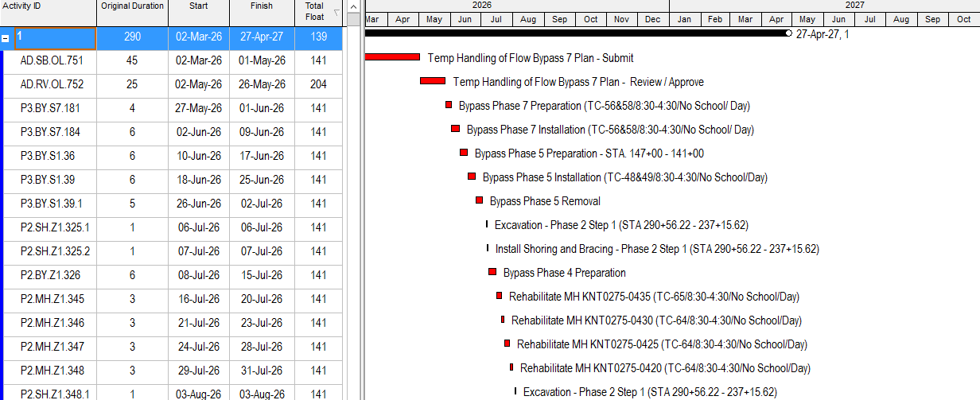

Rain Allowance
███ recorded (1) inclement weather event between 2/2/26 to 3/2/26. The weather events recorded to date are 10/14/25, 11/14/25, 11/17/25,12/31/25, 1/6/26 and 2/19/26. As a result, the Weather Allowance balance has been reduced from 37 to 36 days and remains available for future use.

Changes in Construction Approach
All the changes in our construction approach are shown in our added and deleted logic ties and included in the schedule comparison report.

Potential Issues / Delays
Despite assessing a partial delay at the start to the project the project has been able to gain back the time lost by accelerating the pipe cleaning and grouting for multiple locations.

Planning / Coordination
Any future changes will be communicated via the CPM progress updates and progress meetings.

Activity Updates
All changes incorporated to the current version of attached baseline can be found under the Excel comparison report named “█████ ████████████ - 260302 F00 - SCHEDULE COMPARISON - DD 260202 F01 TO DD 260302 F00.”

Reports and Electronic File included:
- █████ ████████████ - 260202 F00 - SCHEDULE COMPARISON - DD 260202 F00 TO DD 260202 F00.xlsx
- █████ ████████████ - 260202 F00 - SCHEDULE COMPARISON - DD 260202 F00 TO DD 260202 F00.pdf
- █████ ████████████ - 260302 F00 - NARRATIVE.docx

- XER FILE - █████ 260302 F00
- PDF of all cost by bid item - █████ ████████████ – 260302 F00 - ALL WITH COST BY BID ITEM
- PDF of all cost by WBS - █████ ████████████ – 260302 F00 - ALL WITH COST BY WBS
- PDF of the entire schedule with predecessors and successors – █████ ████████████ – 260302 D00 - ALL WITH PREDECESSORS – SUCCESSORS
- PDF of the entire schedule - █████ ████████████ – 260302 F00 – ALL
- PDF of the longest path - █████ ████████████ – 260302 F00 – LONGEST PATH
- PDF of the summary cost - █████ ████████████ - 260302 F00 – LONGEST PATH BY WBS
- Excel spreadsheet of the schedule comparison - █████ ████████████ – 260302 F00 - SCHEDULE COMPARISON REPORT – DD 260202 F01 TO DD 260302 F00
- Narrative - █████ ████████████ – 260302 F00 - NARRATIVE

We look forward to working collaboratively with the Owner and its representatives of the █████████████████████████████████ with issues that may occur with the 260302 F00 schedule.

Sincerely,

██████████████
Project Manager

